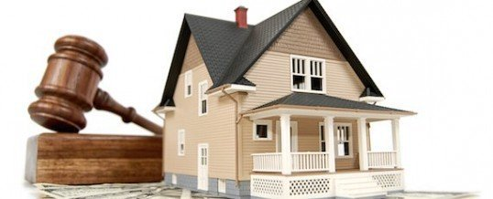3072px-Former_Visa_%28company%29_logo220px-Olddiscover1280px-MasterCard_Logo

**Pay In Person**—Taxes can be paid at the County Treasurer’s Office:

**Monday-Friday, 8 AM-5PM**

**What if I can’t pay the**

**entire amount I owe?**

It is in your best interest to pay as much as you can every month. Continuing to make monthly payments until your entire balance is paid in full will help to reduce the amount of interest and penalty you will pay and reduce the risk of losing your property, contact us with questions. Help may be available through [www.takerootwi.org](http://www.takerootwi.org)

**I still owe taxes from last year, what should I pay first?**

It is advisable to pay your oldest taxes first to avoid the county moving forward with the process to take your property for back taxes.

**What if I am in**

**bankruptcy?**

If you have filed bankruptcy, this notice is informational only and not an attempt to collect a debt.

**What is a Tax Certificate?**

A tax certificate is a lien placed on the property because property taxes, special assessments, special charges or special taxes on your real property were not paid and remain outstanding as of September 1st.

**How do I get rid of the lien from this Tax Certificate?**

To get rid of the lien, you must pay all the property taxes, special assessments, special charges or special taxes that are owed, including interest and penalty.

**How much do I owe?**

The amount that is owed, if paid by September 30th, can be found on the reverse side of this page. **If you pay after September 30th, the amount will continue to increase by 1.5% per month (18% per year) until it is paid in full.**

**What happens if I don’t pay?**

By State law, if you fail to pay the entire amount due within two years of the issuance of the tax

certificate, the county can proceed with steps to take ownership of your property.

**How can I pay?**

You have several payment options:

**Pay By Mail**—Make your check payable to the County Treasurer, write your tax parcel number on the check and mail it to:

**County Treasurer**

**1234—ABC Lane**

**Taxpayer, WI 54321**

**Pay Online**—The County offers residents the option to pay online but it will cost 2.39% for Credit Card payments or $1.50 for E-Checks

Notice of Issuance of tax certificate for tax roll of 2020

Taxpayer County

**Tax Certificate Information**

Continued on back side

To pay online go to

www.paymentportal.com

E-Check

Co

Logo

**This is to advise you that as of September 1, 2021, there are outstanding unpaid 2020 real property taxes,** special assessments, special charges or special taxes on the real property for which you are listed as the owner of record.

On September 1, 2021, I issued a tax certificate to this county for your property as provided in S. 74.57, Wisconsin Statutes. If you fail to pay the outstanding delinquent real property taxes, special assessments, special charges or special taxes, plus interest and penalty, ownership of the property will eventually transfer to the county.

**If there are no outstanding taxes from prior years, this transfer will occur**

**no earlier than two years after issuance of the tax certificate.**