211:
Call 211 or go to 211.org website for referrals to food assistance, paying housing bills, accessing free childcare, or obtaining help with other needs. You will be able to enter your zip code on the website to be connected to your local 211 office. For families with children out of school, several internet broadband providers are providing households with a child in preschool through college with free basic internet service for two months if they do not already have internet service.

Energy (Heating) Assistance:
Wisconsin Home Energy Assistance Program (WHEAP) helps with heating cost, electric cost, and energy crisis situations
- Electric Assistance (Non-Heating) - is a one-time benefit payment during the heating season intended to pay a portion of the household’s electrical (non-heating) costs.
- Crisis Assistance - may be available if you have no heat, have received a disconnect notice, or are nearly out of fuel and do not have the money to purchase more.
- Furnace Assistance - may be available to eligible homeowners or renters if the furnace stops operating.

For more information and how to apply:
- For more information on the Wisconsin Home Energy Assistance Program (WHEAP) and how to apply, please call 1-866-HEATWIS (432-8947), or visit the "Where to Apply" tab on www.homeenergyplus.wi.gov to find your local energy assistance agency. You may also apply online at https://energybenefit.wi.gov/.

Treasurer and Tax
If homeowners are struggling to stay current on their property taxes, they should be in contact with the Treasurer’s Office to discuss options.

*your counties information*
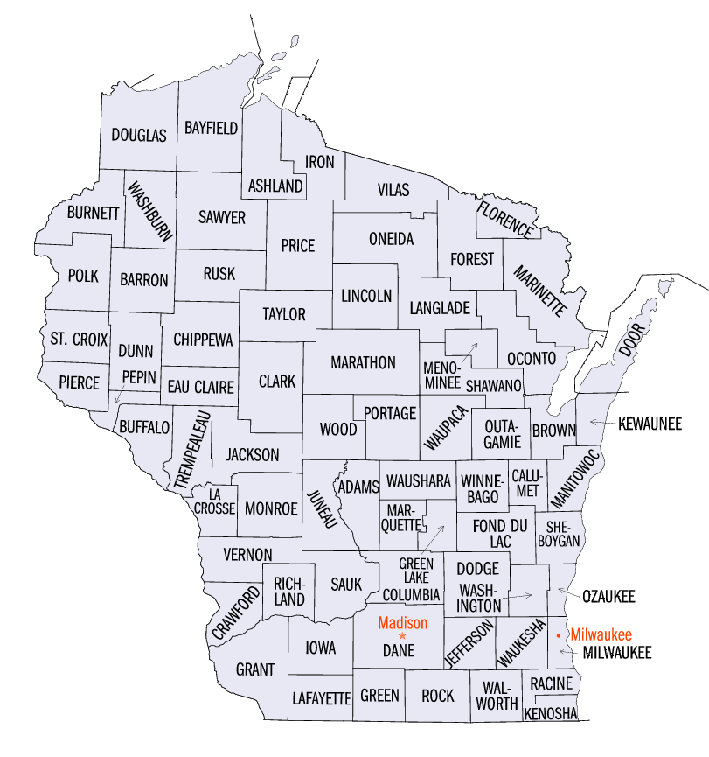
Location and Contact info:
Administration Center
212 6th St North, Room 1900
La Crosse WI

Phone: 608-785-9711
Office Hours: 8am – 4:30pm weekdays

Food Assistance (FoodShare)
FoodShare helps people with limited income buy food.

For adults receiving FoodShare who would like future assistance in finding employment or different employment you can be referred to the FoodShare Employment and Training Program, also known as FSET. This is a voluntary program that helps FoodShare customers build their job skills and find employment. If you are looking for employment or a better job, FSET may be able to help.
To apply online, go to: https://access.wisconsin.gov
To apply by phone or to apply in person, call: 1-888-627-0430
An interview either by phone or in person must be conducted to complete the application process. For more information, go to: http://dhs.wisconsin.gov/foodshare/index.htm

Local Food Pantries
To find your local pantry click on any of the following links:
- https://www.feedingamerica.org/find-your-local-foodbank
  - Click the link and type in your zip code and state and press “Go”
- https://www.foodpantries.org/st/wisconsin
  - Click the link and find your city or a city closest to you
- https://ampleharvest.org/find-pantry/
  - Click the link and type in your zip code and press “Search”

Independent Living Centers

To find your local Independent Living Center click on the following link and find your County on the map, click on the County and it will bring you to the Independent Living Center for your County.
- https://www.dhs.wisconsin.gov/disabilities/physical/ilcs-contact.htm#rivers

Aging and Disability Resource Center

To find your local Aging and Disability Resource Center click on the following link and find your County on the map, click on the County and it will bring you to the Aging and Disability Resource Center for your County.
- https://www.dhs.wisconsin.gov/adrc/consumer/index.htm

BadgerCare Plus
BadgerCare Plus can provide medical coverage to:
- Children under 19 years of age who have income at or below 300% of the Federal Poverty Level. If income is over 300% of the Federal Poverty Level, they may become eligible by meeting a deductible.
- Pregnant women must have income at or below 300% of the Federal Poverty Level. If income is over 300% of the Federal Poverty Level, they may become eligible by meeting a deductible.
- Non-pregnant adults age 19 or older must have income at or below 100% of the Federal Poverty Level to be eligible for BadgerCare Plus.
- Youths exiting out-of-home care, youths who were in foster care, subsidized guardianships, or court-ordered kinship care when they turn 18 will be eligible for BadgerCare Plus up to age 26.
To apply online, go to: https://access.wisconsin.gov
To apply by phone, in person, or to get a paper application, call: 1-888-627-0430
For more information, go to: https://www.dhs.wisconsin.gov/badgercareplus/index.htm

What if I cannot make my mortgage payment?
If you find that you won’t be able to make your next mortgage payment by the due date, contact your lender or servicer right away, before you miss your payment due date or make a partial payment. Your mortgage servicer is the company that sends you the bill for your mortgage payment. If you’re not sure who holds your mortgage, you can call the MERS Servicer Identification System toll-free at 888-679-6377 or www.mersinc.org.
When you contact your servicer write down all the steps you take, such as any phone calls you make and who you talk with, emails you send, and what types of information or documents you have shared. If you need help to figure out your options and the steps to take, contact a HUD-approved housing counselor through HUD’s website at https://apps.hud.gov/offices/hsg/sfh/hcc/fc/

Please as always be aware of scams, if it seems too good to be true it probably is. Scam artists will reach out to you and promise to help you work with your loan servicer or to provide immediate relief from foreclosure. They will usually require an upfront cash payment in order to do this or ask you to sign over the title to your home. Please do not let them take advantage of you. You can receive free housing counseling assistance through the website listed above.

Foundation for Rural Housing – Critical Assistance:
The Foundation for Rural Housing is funded by a grant from the Critical Assistance Program, Community Service Block Grant, Electric Cooperative dollars, and other private donations. They can help with:

- Mortgage assistance
- Utility assistance

Eligibility:
- Client must be able to show they can continue to pay their housing expenses going forward
- Client must show they are spending 30% of their gross income on housing
- Housing cost must be less than 50% of their household gross income
- Client must provide a completed application with verification of income for all household members over the age of 18
- Household income needs to be under 50% of the county median income

Contact Info:
1-888-400-5974 phone
1-608-238-2084 fax
wrh@wisconsinruralhousing.org - email
www.wisconsinruralhousing.org – website

HomeNet.
HomeNet. is an internet assistance program providing families across Wisconsin with home internet access during the school year.
Eligibility:
- Must have 1 child in middle or high school
- Must have a device that is internet accessible
- Must be under 80% county median income
- Home must be able to receive internet
How to Apply:
www.wisconsinruralhousing.org – website
1-608-238-3448 - phone

Consumer Credit Counseling Services
CCCS is affiliated with the National Foundation of Credit Counseling (NFCC) and accredited through the Council of Accreditation. They are a HUD approved counseling agency. Their counseling staff have certifications in housing counseling, student loan counseling, foreclosure prevention, and loss mitigation. They can help with:
- Personal Finance Counseling/Budgeting
- Bankruptcy Counseling/Education
- Improving Credit
- Foreclosure Prevention
- Identity Theft and Scams
- Debt Management
- Wheels Program – to help secure reliable, affordable transportation

For more information on these programs or other services offered, please contact CCCS at:
Toll Free: 1-800-350-2227
Phone: 608-784-8380
Email: info@cccsonline.org
Website: www.cccsonline.org

WISCAP and Community Action Agency
WISCAP- WISCAP is the association of these Community Action Agencies and two Special Purpose Agencies. We are the statewide voice for Community Action Agencies and people struggling with poverty.
Community Action Agencies - In Wisconsin, our 16 Community Action Agencies exist to help people get out of and stay out of poverty. These agencies provide services and coordinate community resources to their local population.
- http://wiscap.org/
Homestead Credit
Click on the link below for more information and how to apply.
- https://www.revenue.wi.gov/Pages/Individuals/homestead.aspx

Rural Development
The Rural Development program within the U.S. Department of Agriculture, also known as the Section 504 Home Repair program, provides loans to very-low-income homeownership to repair, improve, or modernize their homes or provides grants to elderly very-low-income homeowners to remove health and safety hazards.
Fact Sheet: https://www.rd.usda.gov/sites/default/files/fact-sheet/508_RD_FS_RHS_SFH504HomeRepair.pdf
Rural Development Phone Number: (715) 345-7625
Home Repair and Loan Program
Who may apply for this program?
To qualify, you must:
• Be the homeowner and occupy the house
• Be unable to obtain affordable credit elsewhere
• Have a family income below 50 percent of the area median income
• For grants, be age 62 or older and not be able to repay a repair loan

TEMPORARY CRISIS BUDGETING TIPS
A crisis or emergency budget is different from a standard household budget because it helps you identify the items in your budget that are essential and those that are not, which can help you stretch your dollars farther. When an unexpected event happens that drastically affects your finances, you'll need to determine your most important needs and make certain temporary adjustments to your spending in order to pay for those essential needs until things are back to normal for you. You may also need to look for other resources to provide for your needs, such as food pantries, to free up cash for other necessary expenses.

It is important to understand that the changes made do not need to be permanent. Understanding this will make it easier for you to make the decisions on which expenses to cut since you will be able to add them back into your regular monthly budget once the crisis is over.

• Consider reducing services - Can you reduce your cell phone plan? Do you have extra lines or services on your plan that you can remove? Do you need cable TV or can you reduce your plan to help save some money?
• Do you have streaming services (Netflix, Hulu, Disney+, etc)? Can you change the service to the cheaper version with ads? Can you cancel a subscription for a while or eliminate one of them?
• Do you have memberships that you can put on hold or cancel? For example, you can cancel a gym membership and exercise at home. If you have a YMCA membership, talk to member services about free or reduced memberships. They offer those options.
• Do you have monthly subscriptions that can be canceled? Example: Fit Fab Fun Box, Bark Box, BOXYCHARM, Spotify/Apple Music/Google Play, etc.
• Can you eat less “take out” food? Cooking meals at home can save you a lot of money.
• Can you use Food Pantries for items instead of going to the store?
• Are you on the MTU bus route? They are offering free fares through the month of April. This will save money normally spent on fuel for your vehicle.
• Where are your local resale or thrift stores for when you need clothing, shoes, or household items?

LONG TERM TIPS TO DECREASE EXPENSES

Once the immediate crisis has passed and you have regained your regular employment or close to your regular employment you might find that you still have unpaid bills or are behind on certain payments. You may also no longer qualify for the emergency social service programs that you qualified for during the crisis. It will be very important that you still maintain your crisis/emergency budget for as long as you need. There are also other things that you can do in order to maintain a regular monthly budget, especially until you are caught up on your bills. Below are some tips that you can use to help decrease your expenses for your long-term financial health. You might also find some of these suggestions to be helpful during the time you are using your crisis or emergency budget.

1. Write down all your expenses. Be mindful of where you’re spending your pennies and write down everything you spend for a month—you can then see where to cut costs in the future. Trust me, this one really does work.
2. Consider swapping out your cable package for a streaming service, such as Netflix or Hulu.
3. Change your phone deal. Do you really need all those minutes and extras? Is there a cheaper phone deal that will save you money in the long run? Shop around and see what other phone deals are out there.
4. Find groups that rent/swap toys. This way you are not having to buy new toys for your children.
5. Whenever you are shopping, stop and ask yourself why you are buying it and whether you need it or not. Give yourself 10 seconds to consider this for small purchases and 48 hours on large purchase. If you cannot find a good reason, do not buy it. This will help with keep you from making impulse purchases.
6. Shop in thrift stores (at least some of the time). You can find cheap clothing and upcycle it for next to nothing. If you’re looking to update your wardrobe or buy new stuff for your home, check out the cheaper alternatives first.
7. Take a list with you when you go shopping. Buy only those items on the list.
8. Buy the unbranded products in the supermarket.
9. Set up a calendar reminder or automatic payments for your reoccurring bills to avoid late payment fees (they can be upwards of $37)
10. Use the library for free video rentals, books, magazines, and CDs. You can also rent e-books from the library rather than purchasing them from Amazon.
11. Add a few vegetarian meals to your weekly meal plan. Meat can be expensive to buy.
12. Take your own lunch to work. Yes, it’ll take up a few extra minutes of your evening, but wouldn’t you prefer to have an extra $100 at the end of each month instead? Over the course of a year, that’s a saving of over $1,000.
13. Cut out the pricey drinks (energy drinks, coffee shop drinks, sodas, etc). Drink more water. It’s free and you will be healthier.
14. Make your own cleaning supplies instead of buying them. You can research online for the ingredients needed.
15. Turn your lights off. When you leave a room, flick the switch and cut expenses on your electricity bills. If you live with forgetful people, place little stickers by the switch to give people helpful reminders.
16. Replace bulbs with energy saving ones. This will cut expenses and save the environment at the same time.

