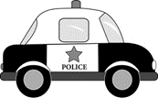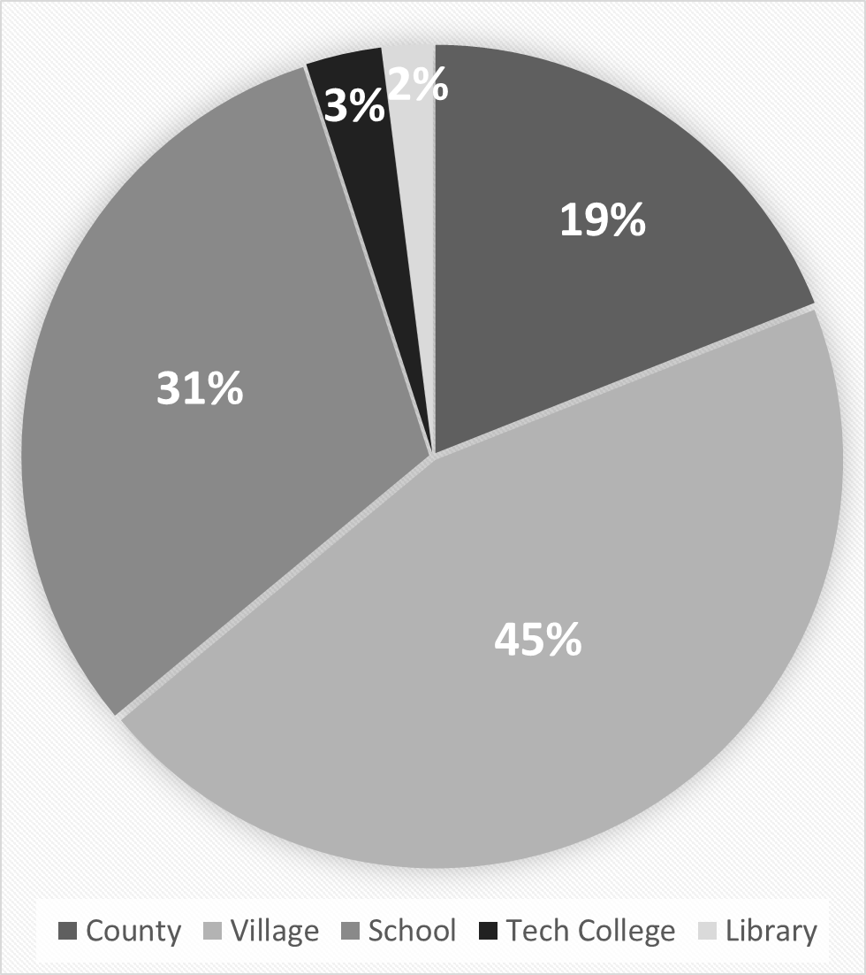

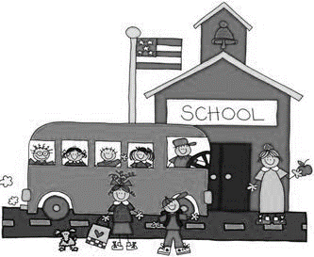

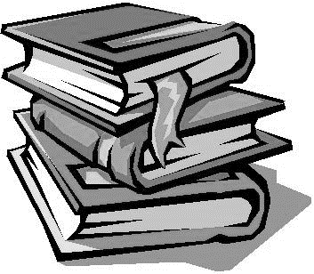

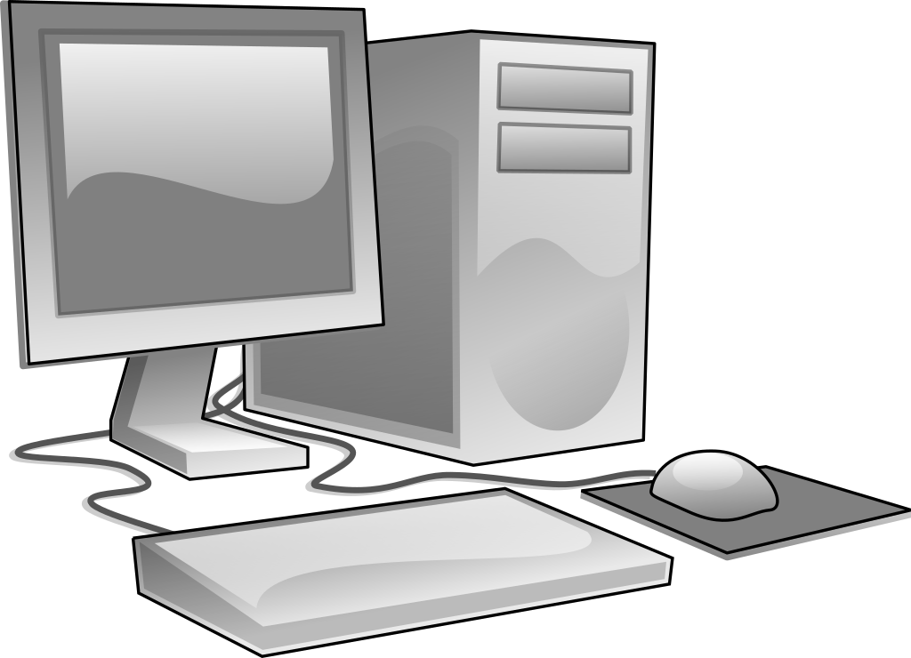

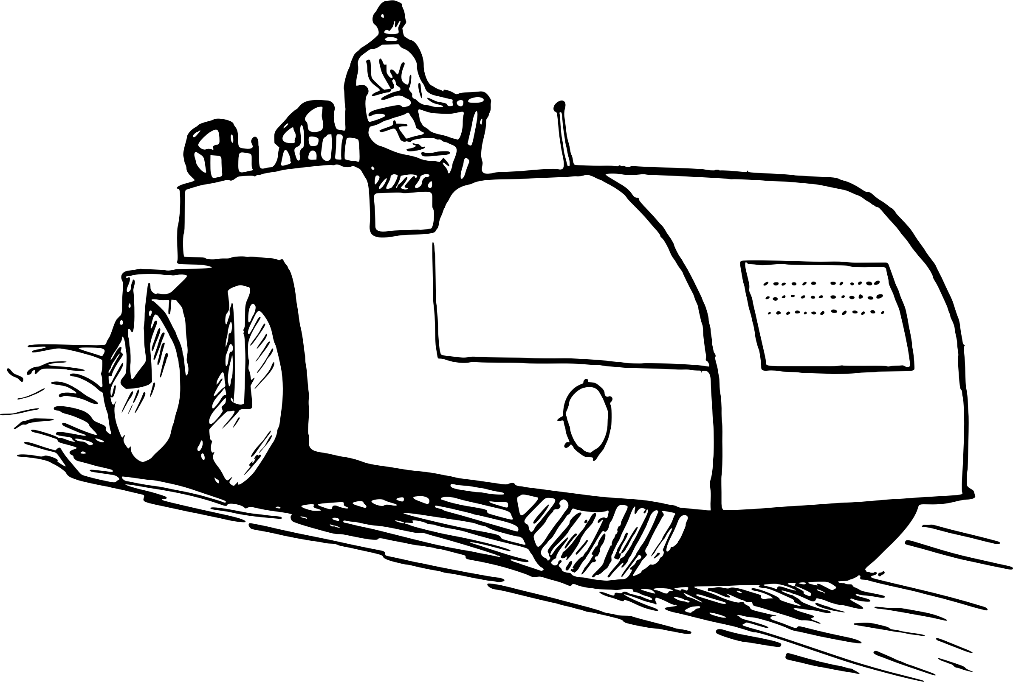

The **Village** to provide basic services such as police, fire, plowing & repairing local roads, garbage pick-up and other items like running elections or doing building inspections

The **School District** to pay for building upkeep, utilities, salaries, furniture, technology and other supplies needed to run our schools

The **County** to provide plowing & repairing County Highways, human services, Circuit Court, jail expenses, veteran’s services and other items like the health department or County Parks

The **Technical College** to make it accessible to more students in our community and to help train workers in skills our community needs

The **Library System** to provide books & services

**Other Charges on Your Bill**

*Your property tax bill may include special taxing districts or special assessment charges for items such as delinquent water bills or repairs made to your property.  If you have questions on any of these charges please visit www.Taxpayervillage.org or call 000-000-0000 for more information.*

**Why should I get the tax bill when my mortgage company pays my taxes?**

Ultimately, it is your property so it is your responsibility to make sure your taxes are paid. Plus, mortgage companies make mistakes, so it is important for you to get your tax bill, and any other tax or assessment notices, so that you can check to make sure they are paying them and charging you the correct amount in your escrow account.

**More information about**

**property taxes can be found at: www.miscwebsite.com**

**How are my taxes calculated?**

Your tax amount is derived by multiplying the value of your property as of January 1, 2020 and the mill rate for all the taxing jurisdictions, then subtracting any applicable credits and adding any special assessments, special charges or special taxes. The amount of your taxes cannot change unless there was an error in the application of one of those things.

**Who can I talk to about the assessed value of my**

**property?**

The Village contracts Big Bad Assessing Co to do our assessments. You may contact them with question at

1-888-123-4567.

**How can I get a receipt?**

Enclose a self-addressed, stamped envelope along with your payment stub and payment. You can also request one in person at the Village Hall. If you paid online, print your receipt from the web site that you used to pay your bill.

**Where is my refund?**

You will not receive a refund unless your payment was more than the entire amount owing. Cash refunds are not given. Refund checks will be issued to whomever paid the tax bill after the check has cleared all banks.

**Where can I see my property information online?**

https://www.kenoshacounty.org/964/Property-Inquiry

Continued from front side

**General Information About Your Property Tax**

**What Does Your Property Tax Payment Support?**